POSTGRE SQL
create table customer_data (
customer_id integer,
credit_score integer,
country varchar(50),
gender varchar(50),
age integer,
tenure integer,
balance numeric(10,2),
products_number integer,
credit_card integer,
active_member integer,
estimated_salary numeric(10,2),
churn integer
)

select * from customer_data

-- REMOVING COLUMN
ALTER TABLE customer_data
DROP COLUMN estimated_salary

-- CATEGORISING DATA
ALTER TABLE customer_data
ADD COLUMN products varchar(50)

UPDATE customer_data
SET products = (SELECT
CASE WHEN products_number = 1 THEN 'prod_1'
WHEN products_number = 2 THEN 'prod_2'
WHEN products_number = 3 THEN 'prod_3'
ELSE 'prod 4'
END AS products)

UPDATE customer_data
SET products = REPLACE(products, 'prod 4', 'prod_4')

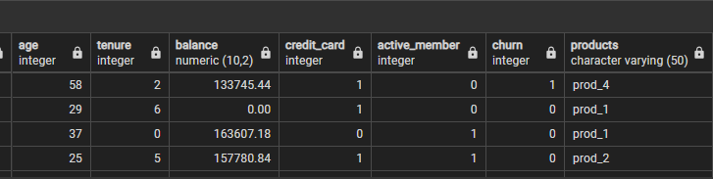

ALTER TABLE customer_data
DROP products_number

RENAMING COLUMNS, CHANGING DATA TYPES AND REPLACING VALUES

ALTER TABLE customer_data
ADD COLUMN credit_card_status VARCHAR(50)

UPDATE customer_data
SET credit_card_status = (SELECT CASE WHEN CAST(credit_card AS integer) = 1 THEN 'Owned'
ELSE 'Not Owned'
END AS credit_card_status)

ALTER TABLE customer_data
DROP COLUMN credit_card

ALTER TABLE customer_data
ADD COLUMN activity_status VARCHAR(50)

UPDATE customer_data
SET activity_status = (SELECT CASE WHEN active_member = 1 THEN 'active'
ELSE 'inactive'
END AS activity_status)

ALTER TABLE customer_data
DROP active_member

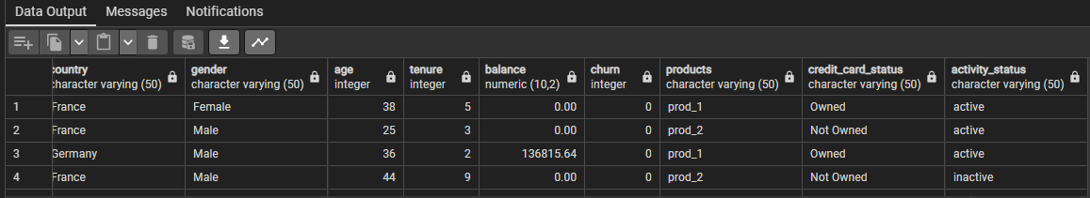

UPDATE customer_data
SET credit_card_status = REPLACE(credit_card_status, 'Owned', 'owned')

UPDATE customer_data
SET credit_card_status = REPLACE(credit_card_status, 'Not', 'not')

ALTER TABLE customer_data
ADD COLUMN churn_status VARCHAR(50)

UPDATE customer_data
SET churn_status = (SELECT
CASE WHEN churn = 0 THEN 'not churned'
ELSE 'churned'
END AS churn_status)

ALTER TABLE customer_data
DROP churn

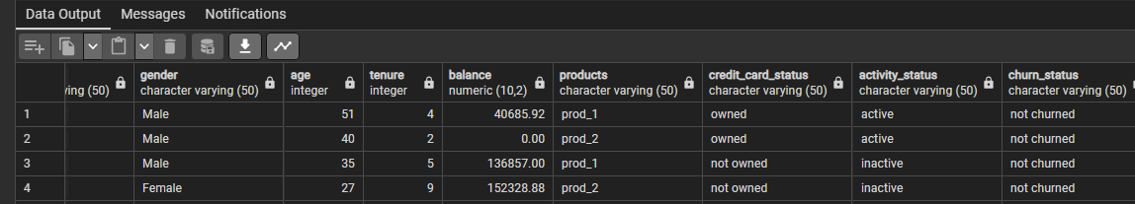

CATEGORISING DATA

-- Creating the age_groups column
ALTER TABLE customer_data
ADD age_groups VARCHAR(50)
-- Populating the age_groups column based on the values in the age column
UPDATE customer_data
SET age_groups = (SELECT CASE WHEN age <= 20 THEN '< 20'
WHEN age <= 30 THEN '21 - 30'
WHEN age <= 40 THEN '31 - 40'
WHEN age <= 50 THEN '41 - 50'
WHEN age <= 60 THEN '51 - 60'
WHEN age <= 70 THEN '61 - 70'
ELSE '> 71'
END AS age_groups)
-- Creating a reference table called age_groups
-- from the customerdata table (duplicating table in Power BI)
select age_groups into age_groups from customer_data
-- Removing Duplicates in the age_groups column of the age_groups table
-- Deleting from a CTE is not possible PostgreSQL. However the relational DB
-- has a special system column called ctid that can temporarily identify each physical row.
-- I used it to delete the duplicates:
WITH cte AS (SELECT
ctid,
age_groups,
ROW_NUMBER() OVER (PARTITION BY age_groups ORDER BY ctid) AS rn
FROM age_groups)

DELETE FROM age_groups
WHERE ctid IN (SELECT ctid FROM cte
WHERE rn > 1);
-- Adding the column age_groups_ID in the age_groups table
ALTER TABLE age_groups
ADD age_groups_ID INTEGER
-- Sorting (re-ordering) the age_groups column of the age_groups table
UPDATE age_groups
SET age_groups_ID = (SELECT CASE WHEN age_groups = '< 20' THEN 1
WHEN age_groups = '21 - 30' THEN 2
WHEN age_groups = '31 - 40' THEN 3
WHEN age_groups = '41 - 50' THEN 4
WHEN age_groups = '51 - 60' THEN 5
WHEN age_groups = '61 - 70' THEN 6
ELSE 7
END AS age_groups_ID)

select * from age_groups

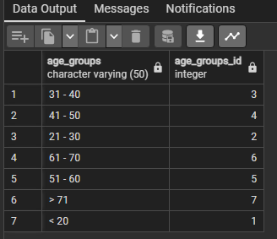

-- Creating the credit_scores column
select * from customer_data
alter table customer_data
add credit_scores varchar(50)
-- Populating the credit_scores column based on the values in the credit_score column
update customer_data
set credit_scores = (select case when credit_score <= 400 then '<= 400'
when credit_score <= 500 then '401 - 500'
when credit_score <= 600 then '501 - 600'
when credit_score <= 700 then '601 - 700'
when credit_score <= 800 then '701 - 800'
when credit_score >= 800 then '>= 800'
end as credit_scores)
-- Creating a reference table called credit_score_groups
-- from the customer_data table (duplicating table in Power BI)
select credit_scores into credit_score_groups from customer_data
select * from credit_score_groups
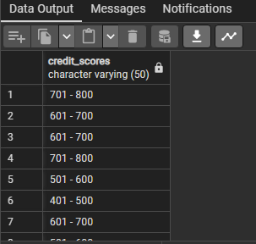

-- Removing Duplicates in the credit_scores column of the credit_score_groups table
-- Deleting from a CTE is not possible PostgreSQL. However the relational DB
-- has a special system column called ctid that can temporarily identify each physical row.
-- I used it to delete the duplicates:
WITH cte AS (SELECT
ctid,
credit_scores,
ROW_NUMBER() OVER (PARTITION BY credit_scores ORDER BY ctid) AS rn
FROM credit_score_groups)

DELETE FROM credit_score_groups
WHERE ctid IN (SELECT ctid FROM cte
WHERE rn > 1);
-- Adding the column credit_score_ID in the credit_score_groups table
ALTER TABLE credit_score_groups
ADD credit_score_ID INTEGER
-- Sorting (re-ordering) the credit_scores column of the credit_score_groups table
select * from credit_score_groups
UPDATE credit_score_groups
SET credit_score_ID = (SELECT CASE WHEN credit_scores = '<= 400' THEN 1
WHEN credit_scores = '401 - 500' THEN 2
WHEN credit_scores = '501 - 600' THEN 3
WHEN credit_scores = '601 - 700' THEN 4
WHEN credit_scores = '701 - 800' THEN 5
ELSE 6
END AS credit_score_ID)

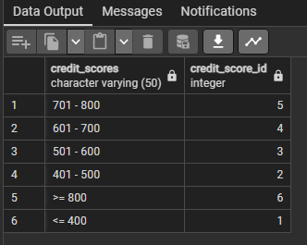

-- Creating the account_balance column
ALTER TABLE customer_data
ADD account_balance VARCHAR(50)
-- Populating the account_balance column based on the values in the balance column
update customer_data
set account_balance = (select case when balance = 0 then '0'
when balance <= 1000 then '1 - 1k'
when balance <= 10000 then '1k - 10k'
when balance <= 100000 then '10k - 100k'
when balance <= 200000 then '100k - 200k'
when balance > 200000 then '> 200k'
end as account_balance)

-- Creating a reference table called Account_balance_groups
-- from the customer_data table (duplicating table in Power BI)
select account_balance into account_balance_groups from customer_data
select * from account_balance_groups

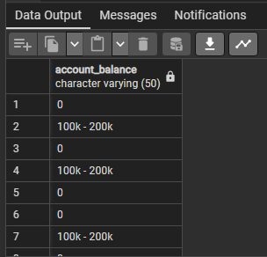
-- Removing Duplicates in the account_balance column of the account_balance_groups table
-- Deleting from a CTE is not possible PostgreSQL. However the relational DB
-- has a special system column called ctid that can temporarily identify each physical row.
-- I used it to delete the duplicates:
WITH cte AS (SELECT
ctid,
account_balance,
ROW_NUMBER() OVER (PARTITION BY account_balance ORDER BY ctid) AS rn
FROM account_balance_groups)

DELETE FROM account_balance_groups
WHERE ctid IN (SELECT ctid FROM cte
WHERE rn > 1);

-- Adding the column account_balance_ID in the account_balance_groups table
ALTER TABLE account_balance_groups
ADD account_balance_ID INTEGER
-- Sorting (re-ordering) the credit_scores column of the credit_score_groups table
select * from account_balance_groups
UPDATE account_balance_groups
SET account_balance_ID = (SELECT CASE WHEN account_balance = '0' THEN 1
WHEN account_balance = '1k - 10k' THEN 2
WHEN account_balance = '10k - 100k' THEN 3
WHEN account_balance = '100k - 200k' THEN 4
WHEN account_balance = '> 200k' THEN 5
END AS account_balance_id)

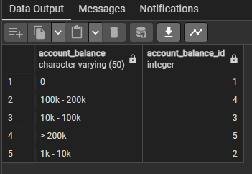

REPLICATING DAX MEASURES IN SQL

select * from customer_data
SELECT COUNT(customer_id) AS total_number_of_customers FROM customer_data

-- total number of customers lost
SELECT COUNT(customer_id) AS total_number_of_customers FROM customer_data
WHERE churn_status = 'churned'

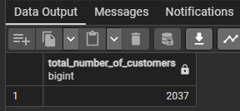

-- churn rate
SELECT ROUND(COUNT(customer_id) * 100.00 / (SELECT COUNT(customer_id) FROM customer_data),1) AS
churn_rate
FROM customer_data
WHERE churn_status = 'churned'

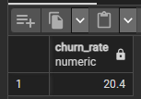

POWER BI VISUALS REPLICATED IN SQL

-- Total Number of Customers and percentage by gender
select * from customer_data
select gender, COUNT(customer_id) AS count_of_customers,
ROUND(COUNT(customer_id) * 100.00 / (select COUNT(customer_id) from customer_data),2)
AS pct
from customer_data
group by gender
-- Total Number of Customers and percentage by activity_status
select activity_status, COUNT(customer_id) AS count_of_customers,
ROUND(COUNT(customer_id) * 100.00 / (select COUNT(customer_id) from customer_data),2)
AS pct
from customer_data
group by activity_status
-- Total Number of Customers and percentage by credit_card_status
select credit_card_status, COUNT(customer_id) AS count_of_customers,
ROUND(COUNT(customer_id) * 100.00 / (select COUNT(customer_id) from customer_data),2)
AS pct
from customer_data
group by credit_card_status
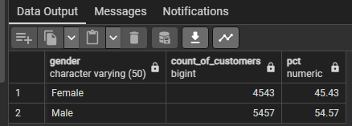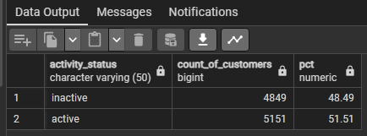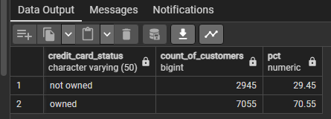
-- Total number of customers and churn rate (avg churn per customer)
-- broken down by age_groups and sorting (age_groups_id)
select ag.age_groups, ag.age_groups_id,
COUNT(c.customer_id) AS total_number_of_customers,
SUM(CASE WHEN c.churn_status = 'churned' THEN 1 ELSE 0 END) * 100.00 /
COUNT(c.customer_id) AS AVG_churn_per_customer
from customer_data c
inner join age_groups ag on ag.age_groups = c.age_groups
group by ag.age_groups, ag.age_groups_id
order by ag.age_groups_id
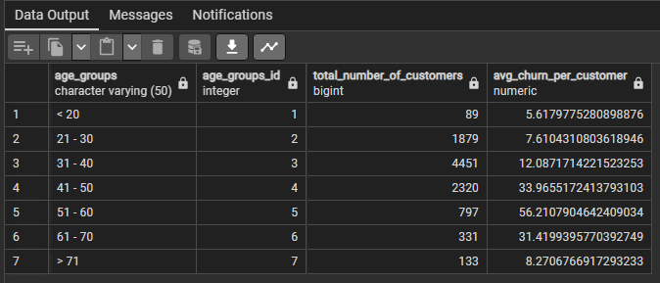
-- Total number of customers and AVG churn per customer
-- broken down by credit scores and credit scores ID
select csg.credit_scores, csg.credit_score_id,
COUNT(c.customer_id) AS total_number_of_customers,
ROUND(SUM(CASE WHEN c.churn_status = 'churned' THEN 1 ELSE 0 END) * 100.00 /
COUNT(c.customer_id),2) AS AVG_churn_per_customer
from customer_data c
inner join credit_score_groups csg on csg.credit_scores = c.credit_scores
group by csg.credit_scores, csg.credit_score_id
order by csg.credit_score_id
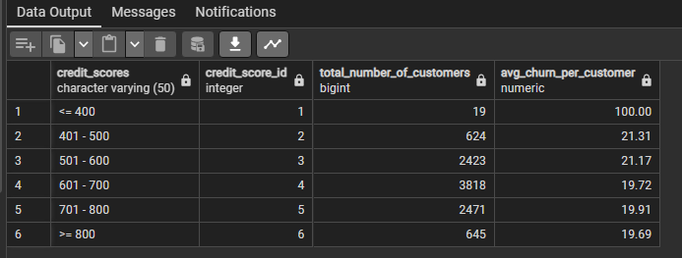
-- Total number of customers and churn rate
-- broken down by account balance and account balance ID
select abg.account_balance, abg.account_balance_id,
COUNT(c.customer_id) AS count_of_customers,
SUM(CASE WHEN churn_status = 'churned' THEN 1 ELSE 0 END) * 100.00 /
COUNT(c.customer_id) AS churn_rate
from customer_data c
inner join account_balance_groups abg on c.account_balance = abg.account_balance
group by abg.account_balance, abg.account_balance_id
order by abg.account_balance_id
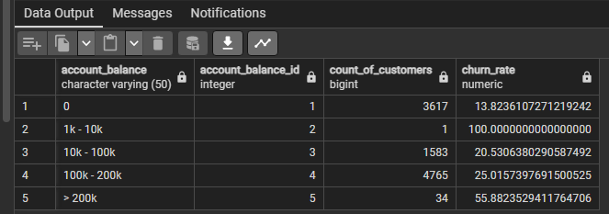
-- ADD THE TARGET CHURN RATE COLUMN
ALTER TABLE customer_data
ADD target_churn_rate DECIMAL(10,2)
-- SET A TARGET RATE OF 0.15 (15%)
UPDATE customer_data
SET target_churn_rate = 0.15
-- AVG CHURN RATE PER CUSTOMER AND TARGET_CHURN_RATE IN PCT
select target_churn_rate,
SUM(CASE WHEN churn_status = 'churned' THEN 1 ELSE 0 END) * 100.00 /
(SELECT COUNT(customer_id) from customer_data) AS AVG_churn_rate_per_customer ,
target_churn_rate * 100.00 AS target_churn_rate_pct
FROM customer_data
group by target_churn_rate
